# Apply filters to SQL queries

## Project description

My organization is actively working to enhance the security of its system. It is my responsibility to guarantee the safety of the system, examine any possible security concerns, and update employee computers as required. The subsequent steps illustrate how I utilized SQL with filters to carry out security-related tasks.

## Retrieve after hours failed login attempts

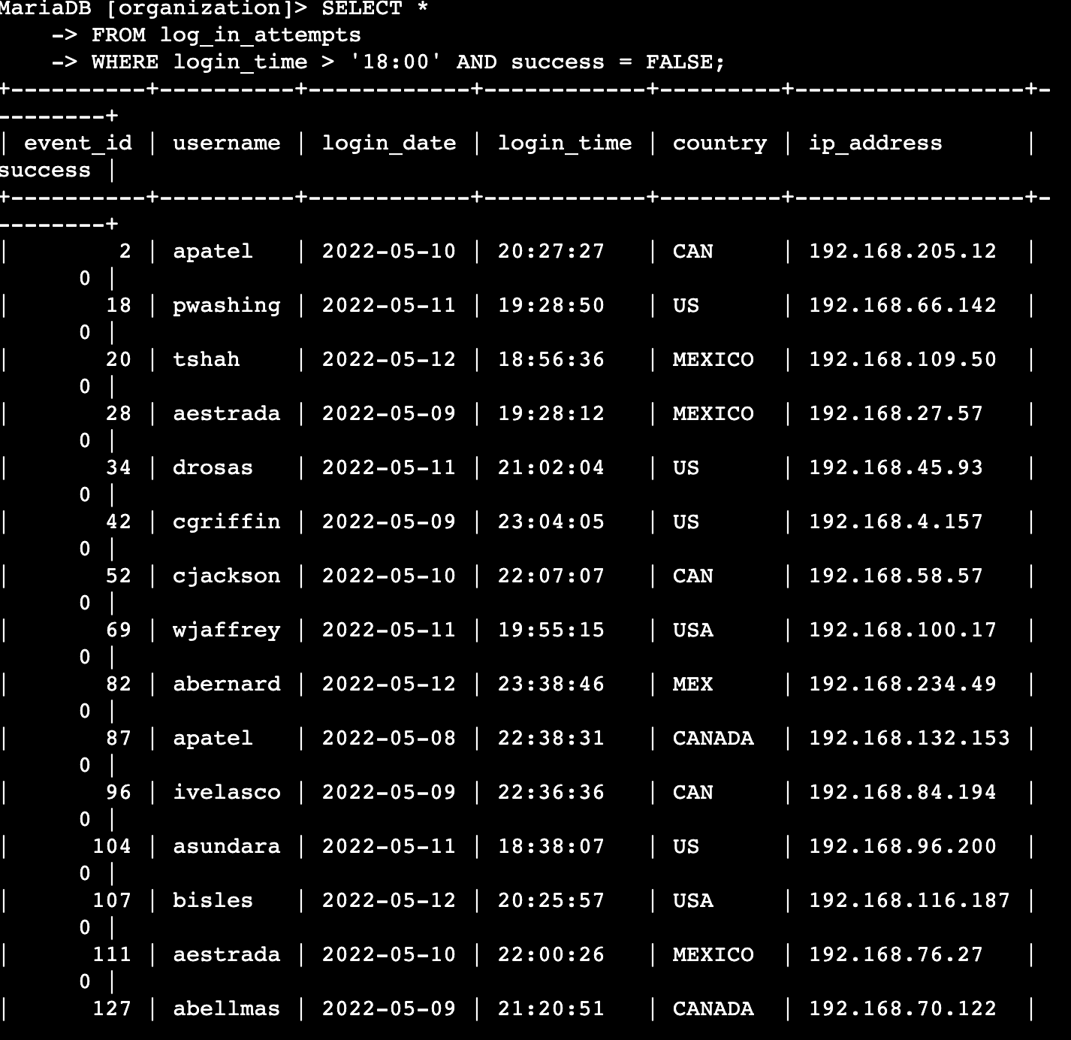

The first line ‘select *’ represents that we are searching on all columns

The next like ‘from log_in_attempts’ represents the database we are searching from, in this case, log_in_attempts.

And lastly, the where condition is telling us to search for results where the login happened after 6:00 p,m as well as when the login attempt failed (success = false)

## Retrieve login attempts on specific dates

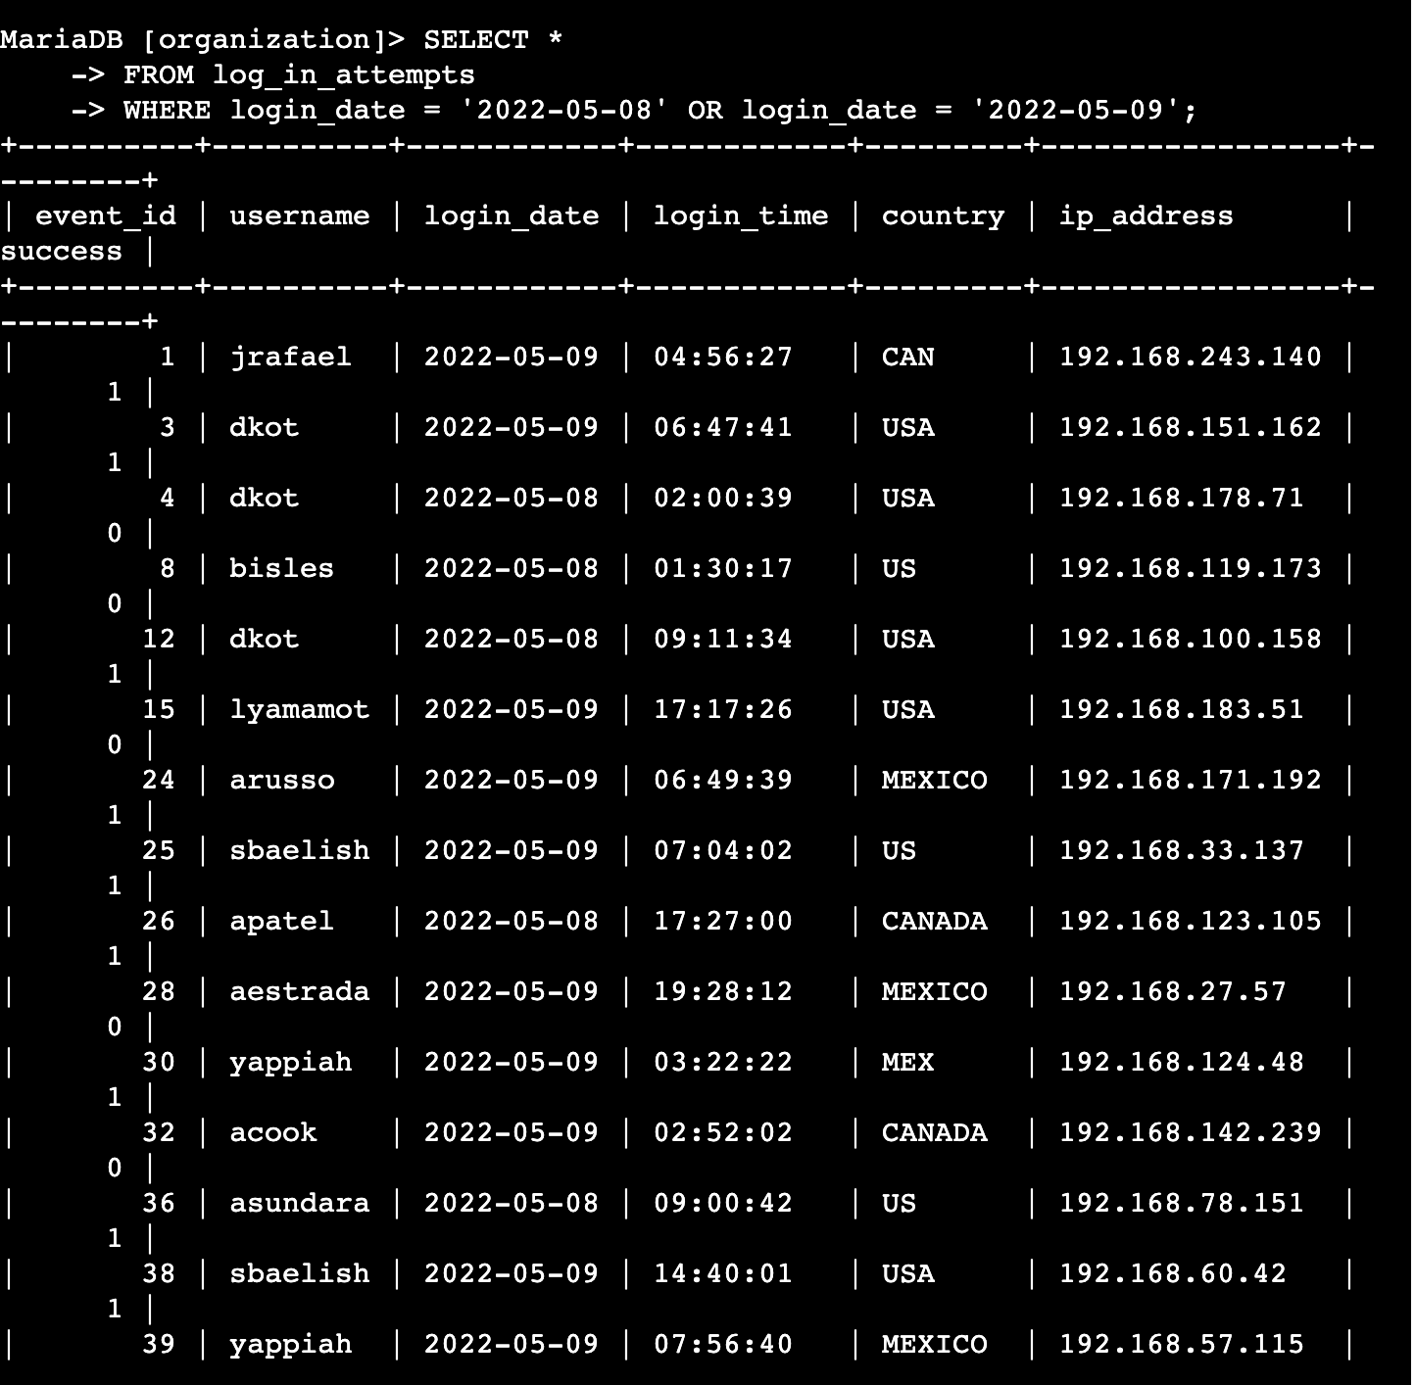

To access the login on one or more specific dates, we use the ‘where’ query combined with the ‘or’ query. This gives us results for either of the dates, in this case, May 9th or May 8th.

## Retrieve login attempts outside of Mexico

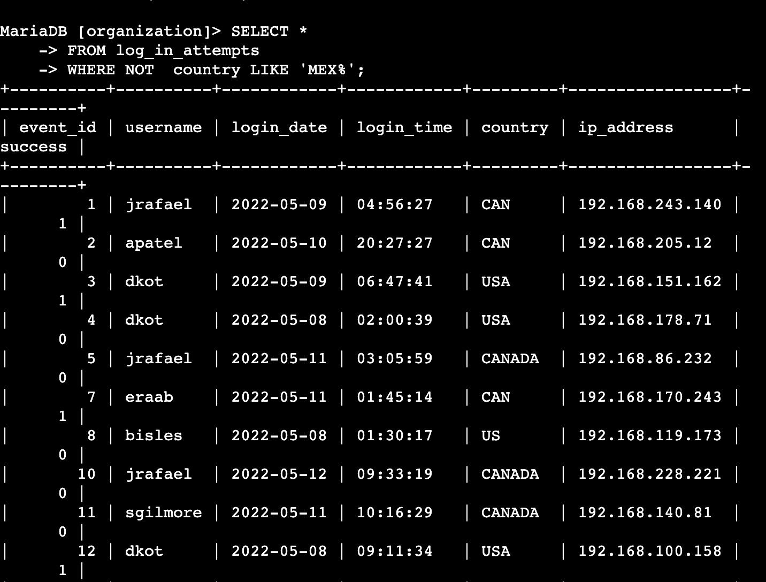

There’s been suspicious activity with login attempts, but the team has determined that this activity didn't originate in Mexico. To investigate login attempts outside of Mexico, I used another query. ‘WHERE NOT’ will give me results that are not in Mexico, and I used the “LIKE ‘MEX%’ query since in the database, Mexico is written either as MEXICO OR MEX. Using MEX% will give me results for both names.

## Retrieve employees in Marketing

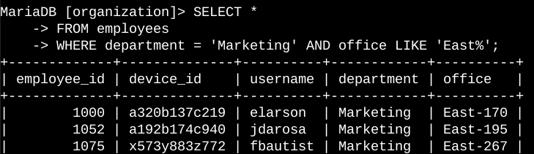

My next search was for employees in the marketing department who also had their office in the east building. To do this, I used the WHERE and AND operators to combine my search for both. I also used the LIKE East% to include all offices in the East building.

## Retrieve employees in Finance or Sales

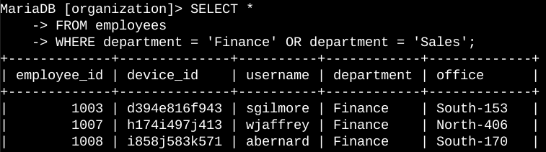

To retrieve this information, I used the OR query to update my search for employees in either one department or both departments.

## Retrieve all employees not in IT

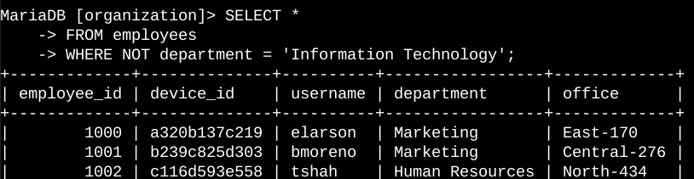

To obtain all results for employees not in information technology, I utilized the NOT function to exclude IT and include all other employees.

## Summary

I implemented filters in SQL queries to extract detailed information regarding login attempts and employee machines. I worked with two distinct tables: log_in_attempts and employees. To obtain the precise information required for each task, I utilized the AND, OR, and NOT operators. Additionally, I employed the LIKE operator along with the percentage sign (%) wildcard to search for specific patterns.